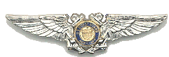

District 7 Auxiliary Aviation
Effective 1 January 2009

Contact information for the DFSO is:

lbertman@comcast.net

Mobile 772-559-4871 (voicemail messages will be returned)
Home 772-492-7187 (please do not leave voicemail)

Island work numbers below: (I travel to work in Anguilla 2-3 weeks per month.) These are US telephone numbers so no foreign calling charges will be incurred:

Mobile 772-409-6674 (please do not leave voicemail)
Business 305-590-8097 x407 (please do not leave voicemail)

Lee Bertman, DFSO D7

